**Hive Mini Project 1**

**1. Create a schema based on the given dataset**

**hive> create table Agent_login_report**

**> (**

**> sl_no int, Agent string, Date date, login_time string, logout_time string, duration string**

**> )**

**> row format delimited**

**> fields terminated by ','**

**> tblproperties ("skip.header.line.count" = "1");**

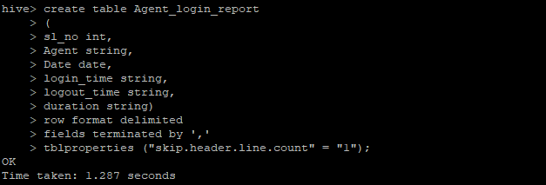

**hive> create table Agent_Performance**

**> (**

**> sl_no int, Date date, Agent_name string, total_chats int, average_response_time string,**

**> average_resolution string, average_rating float, total_feedback int**

**> )**

**> row format delimited**

**> fields terminated by ','**

**> tblproperties ("skip.header.line.count" = "1");**

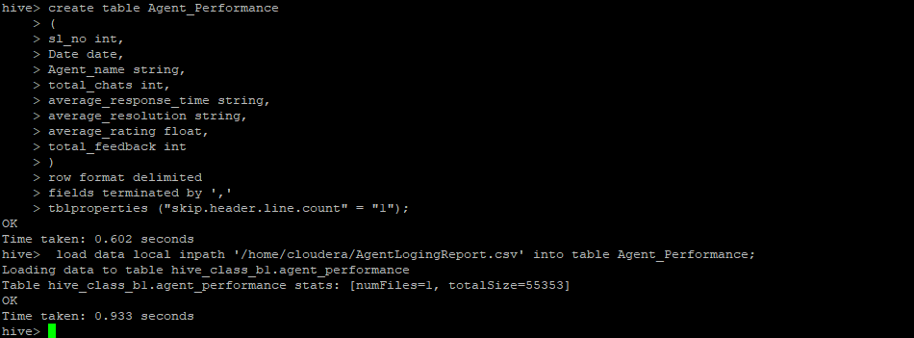

**2. Dump the data inside the hdfs in the given schema location.**

hive> load data local inpath '/home/cloudera/AgentLogingReport.csv' into table Agent_login_report;

hive> load data local inpath '/home/cloudera/AgentLogingReport.csv' into table Agent_Performance;

**3. List of all agents' names.**

Hive> select Agent from Agent_login_report;

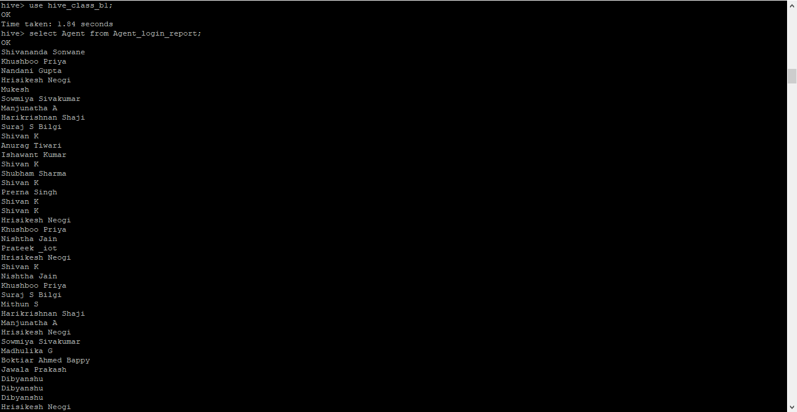

**4. Find out agent average rating.**

hive> select agent_name, avg(average_rating) as average_rating from Agent_Performance group by agent_name limit 5;

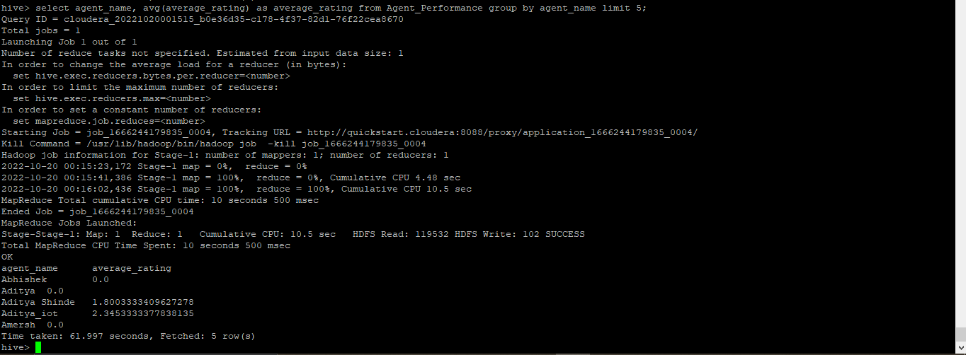

**5. Total working days for each agents**

hive> select agent_name, count(date) as Total_working_days from Agent_Performance group by agent_name limit 5;

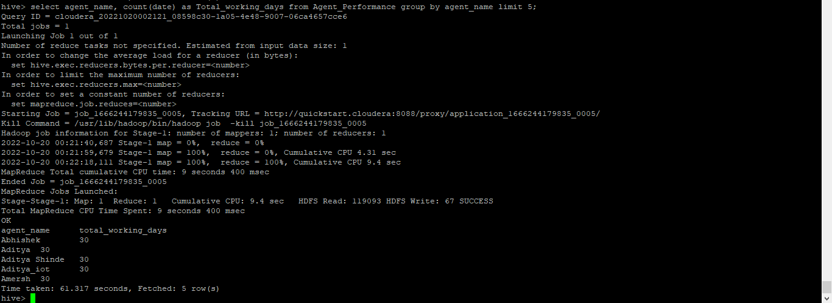

**6. Total query that each agent have taken**

hive> select agent_name, sum(Total_chats)as Total_query_taken from Agent_Performance group by agent_name limit 5;

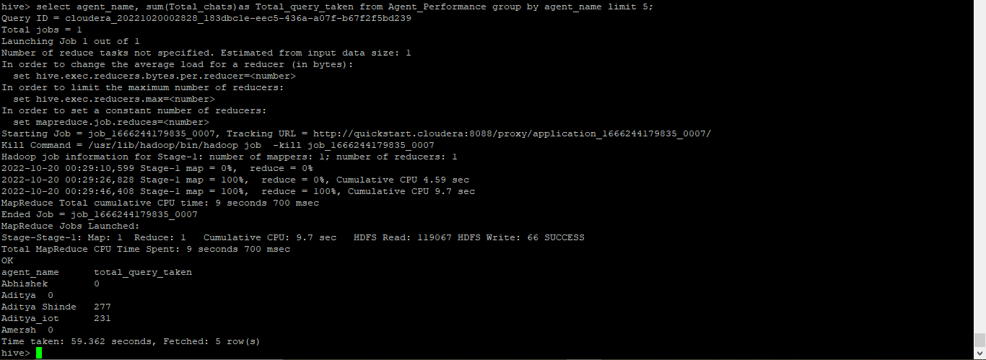

**7. Total Feedback that each agent have received**

hive> select agent_name, sum(Total_feedback)as Total_feedback from Agent_Performance group by agent_name limit 5;

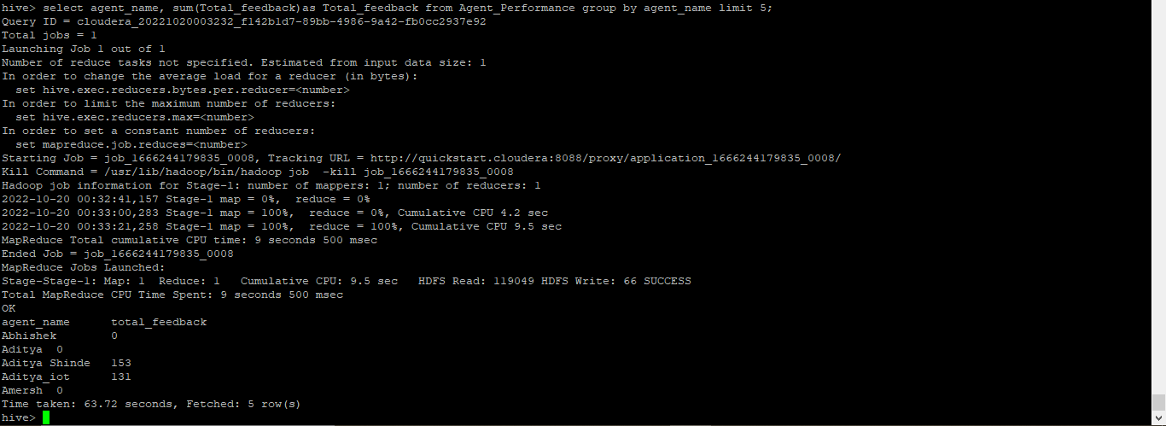

**8. Agent name who have average rating between 3.5 to 4**

hive> select agent_name from Agent_Performance where average_rating BETWEEN 3.5 AND 4 limit 5;

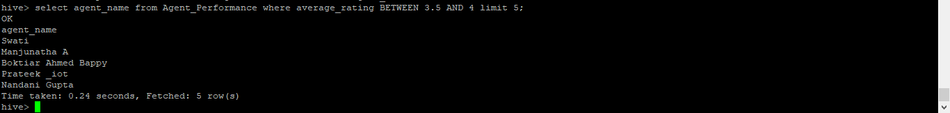

**9. Agent name who have rating less than 3.5**

hive> select agent_name from Agent_Performance whereaverage_rating < 3.5 limit 5;

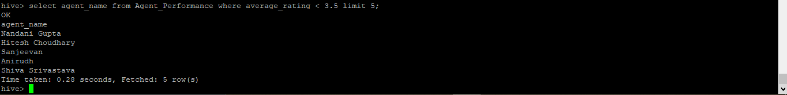

**10. Agent name who have rating more than 4.5**

hive> select agent_name from Agent_Performance where average_rating > 4.5 limit 5;

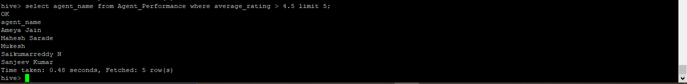

**11. How many feedback agents have received more than 4.5 average**

hive> select agent_name, avg(total_feedback) as Avg_feedback from Agent_Performance group by agent_name having Avg_feedback > 4.5 limit 5;

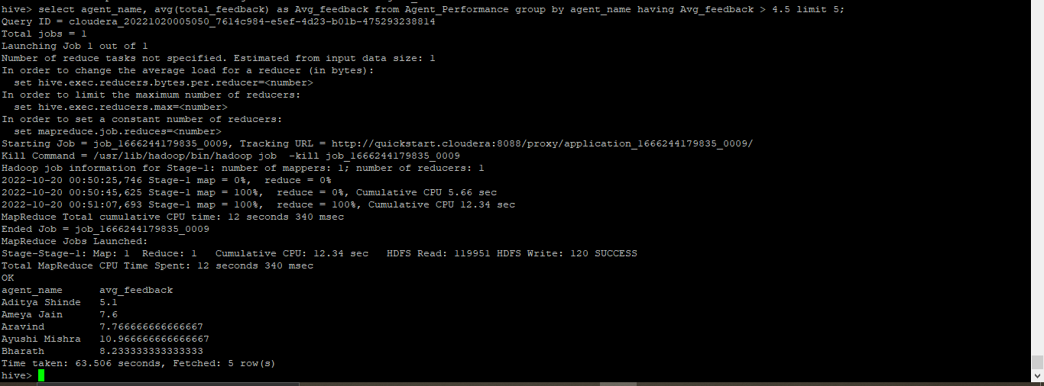

**12. average weekly response time for each agent**

hive> select s.agent_name, avg(col1[0]*3600+col1[1]*60+col1[2])/3600 from(select agent_name, split(average_response_time,':')as col1 from Agent_Performance)s group by s.agent_name limit 5;

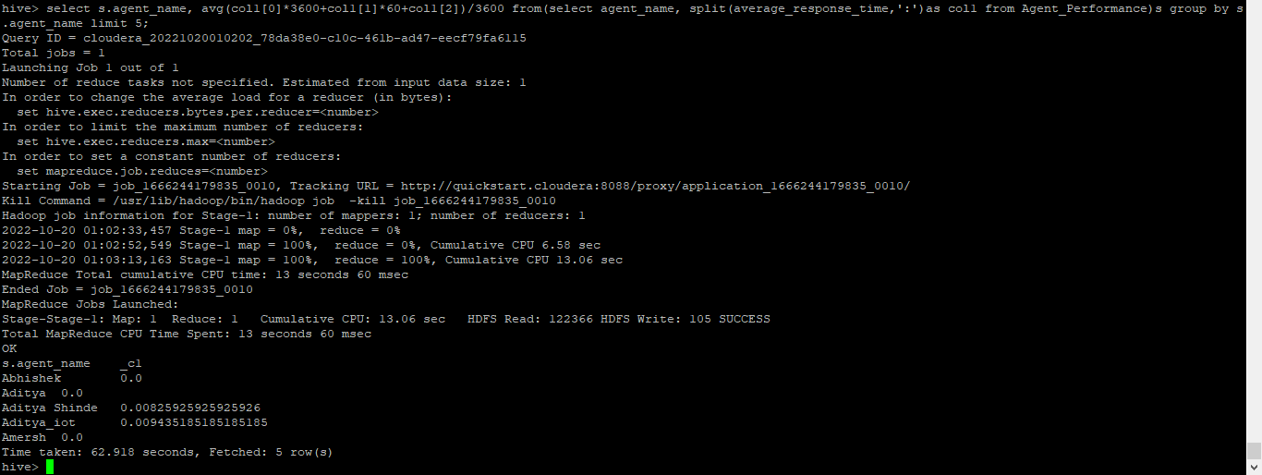

**13. average weekly resolution time for each agents**

hive> select s.agent_name, avg(col1[0]*3600+col1[1]*60+col1[2])/3600 as weekly_resolution_time from(select agent_name, split(Average_resolution_time,':')as col1 from Agent_Performance)s group by s.agent_name limit 5;

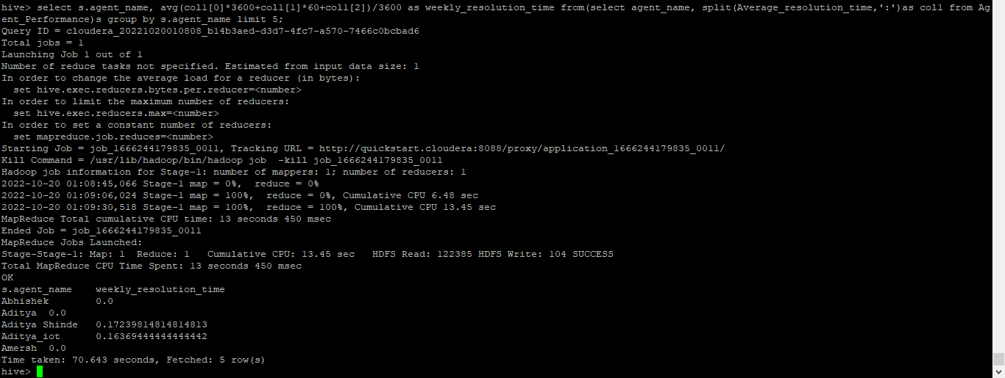

**14. Find the number of chat on which they have received a feedback**

hive> select agent_name, sum(total_chats), total_feedback from Agent_Performance where total_feedback > 0 group by agent_name, total_feedback limit 5;

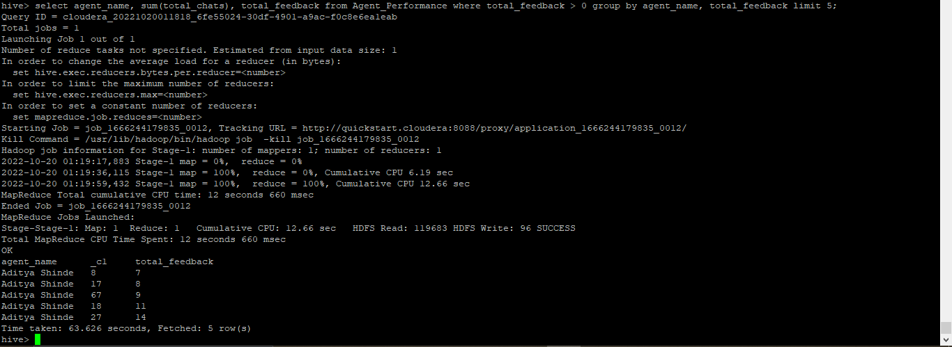

**15. Total contribution hour for each and every agents weekly basis**

hive> select s.Agent,sum(col1[0]*3600+col1[1]*60+col1[2])/3600,s.weekly from(select Agent,split(duration,':') as col1 ,weekofyear(Date) as weekly from Agent_login_report)s group by s.Agent,s.weekly limit 2;

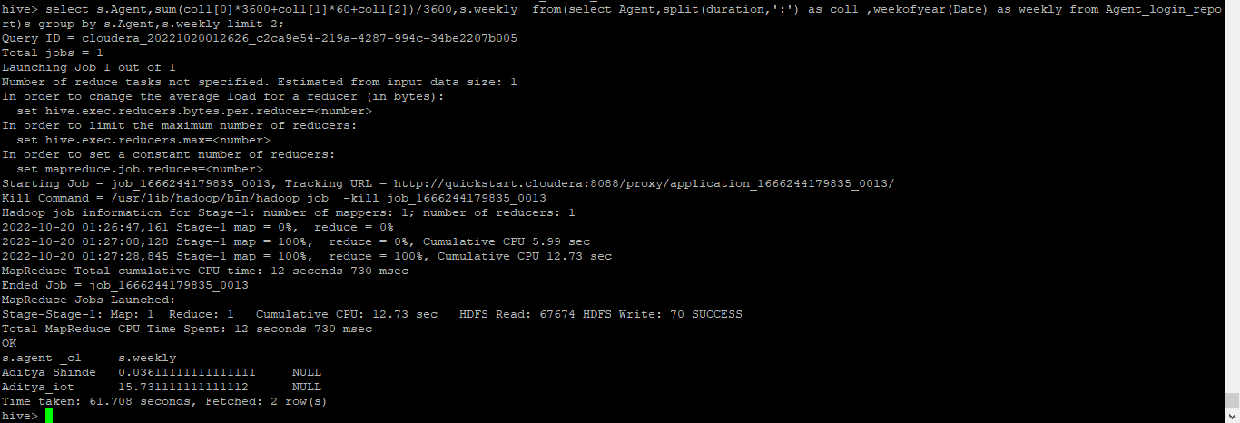

**16. Perform inner join, left join and right join based on the agent column and after joining the table export that data into your local system.**

**INNER JOIN**

hive> Select a.Agent,a.Date,b.total_chats,b.total_feedback from hive_class_b1.Agent_login_report a join hive_class_b1.Agent_Performance b on a.agent = b.agent_name limit 5;

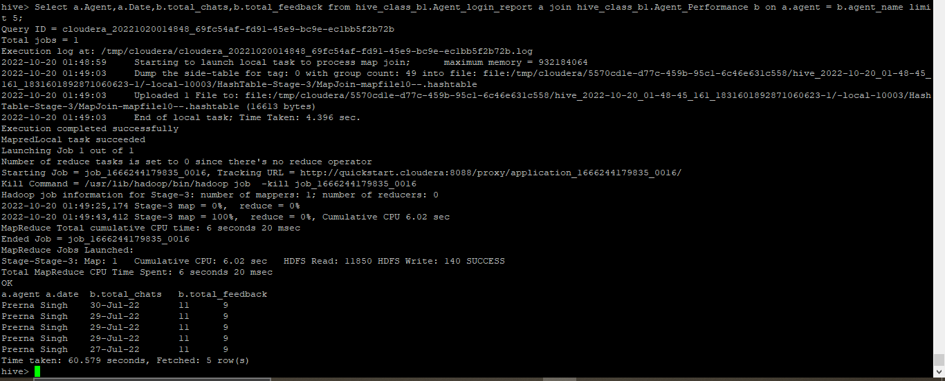

**LEFT JOIN**

hive> Select a.Agent,a.Date,b.total_chats,b.total_feedback from hive_class_b1.Agent_login_report a left join hive_class_b1.Agent_Performance b on a.agent = b.agent_name limit 5;

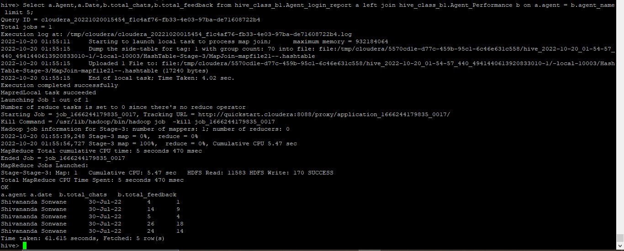

**RIGHT JOIN**

hive> Select a.Agent,a.Date,b.total_chats,b.total_feedback from hive_class_b1.Agent_login_report a right join hive_class_b1.Agent_Performance b on a.agent = b.agent_name limit 5;

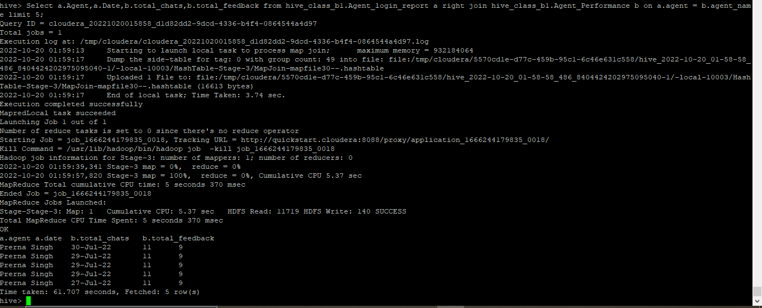

**Saving the output into csv file by using following command in cli**

[cloudera@quickstart ~]$ hive -e 'select a.Agent,a.Date,b.total_chats,b.total_feedback from hive_class_b1.Agent_login_report a join hive_class_b1.Agent_Performance b on a.agent = b.agent_name limit 5' /home/cloudera/hive_mini_project/inner_join.csv;

[cloudera@quickstart ~]$ hive -e 'select a.Agent,a.Date,b.total_chats,b.total_feedback from hive_class_b1.Agent_login_report a left join hive_class_b1.Agent_Performance b on a.agent = b.agent_name limit 5' /home/cloudera/hive_mini_project/left_join.csv;

[cloudera@quickstart ~]$ hive -e 'select a.Agent,a.Date,b.total_chats,b.total_feedback from hive_class_b1.Agent_login_report a right join hive_class_b1.Agent_Performance b on a.agent = b.agent_name limit 5' /home/cloudera/hive_mini_project/right_join.csv;

**17. Perform partitioning on top of the agent column and then on top of that perform bucketing for**

**each partitioning.**

hive> create table Alr_part_buck

> (sl_no int,Date string,login_time string,logout_time string,duration string)

> partitioned by (Agent string)

> clustered by (Date) sorted by (Date) into 4 buckets

> row format delimited

> fields terminated by ',';

hive> set hive.exec.dynamic.partition=true;

hive> set hive.exec.dynamic.partition.mode=nonstrict;

hive> insert into table Alr_part_buck partition(Agent) select sl_no,Date,login_time,logout_time,duration,Agent from Agent_login_report;

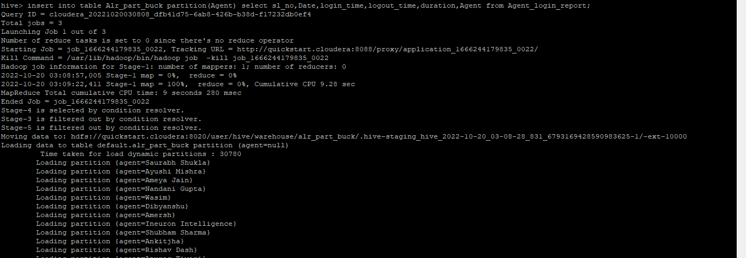

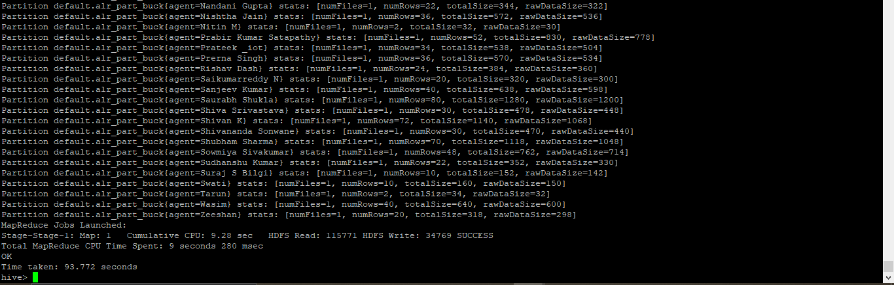

hive> Create table AP_partition_Bucket

> (

> sl_no int,date string,total_chats int,average_response_time string,average_resolution_time string,average_rating float,total_feedback int

> )

> partitioned by (agent_name string)

> CLUSTERED BY (Date) sorted by (Date) INTO 8 BUCKETS

> ROW FORMAT DELIMITED

> FIELDS TERMINATED BY ',';

hive> insert into table AP_partition_Bucket partition(agent_name) select sl_no,date,total_chats, average_response_time, average_resolution_time,average_rating,total_feedback,agent_name from Agent_Performance;

